Michael Amanti
Ramsey Theory

Definitions

Complete graph: A graph where every vertex is connected to all other vertices by exactly one edge.

Pigeonhole property: The principle that if you have n being put into m placeholders, where n>m than at least one placeholder must have more than one item in it.

Show that in a group of six people it is definitive that there will be at least three people who know each other or three people who do not know each other.

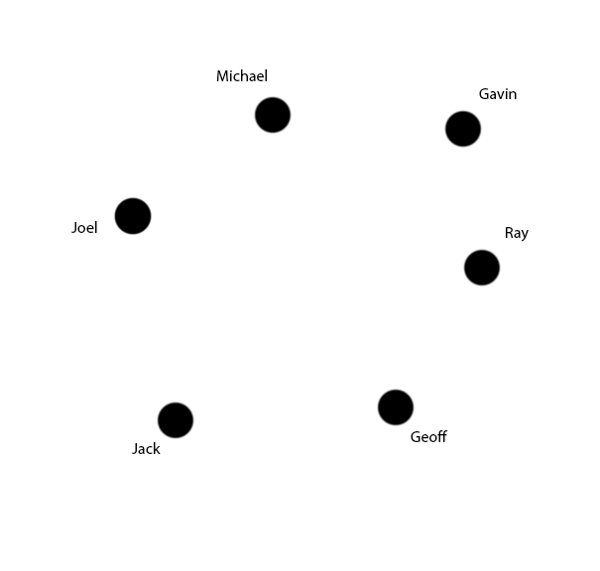
Now show an example of how in a group of five people this can be seen as not true necessarily.

